ROBOMANIPAL TASK-4

SWITCHES-

OR GATE-
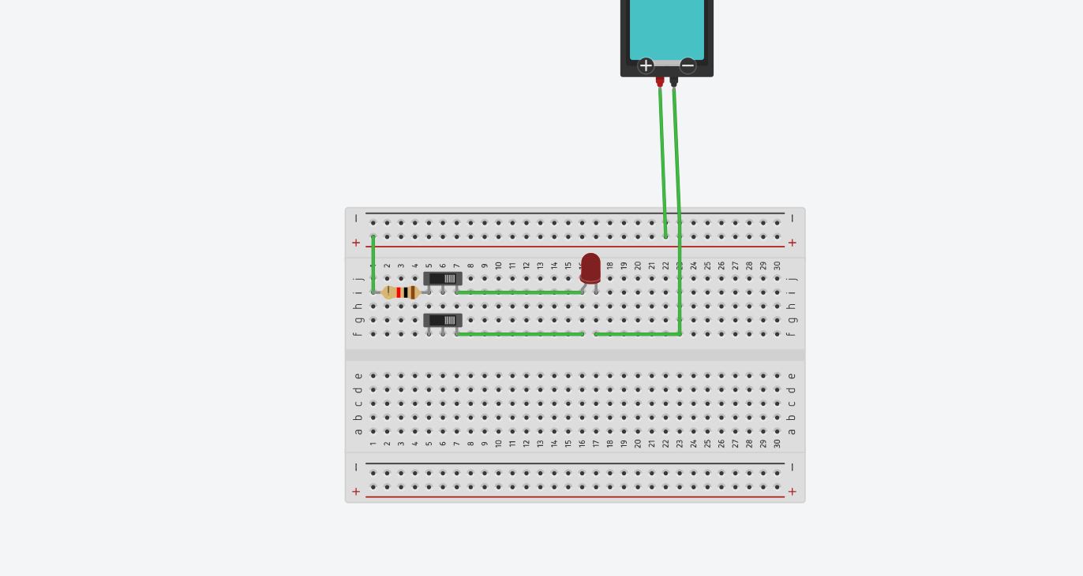
https://www.tinkercad.com/things/7oBQQxa7SKS-or-gate?sharecode=cjrfmLlt6BR1oazx_JNOs5txc1nLqLX8WO3g6VAUQx0

AND GATE-
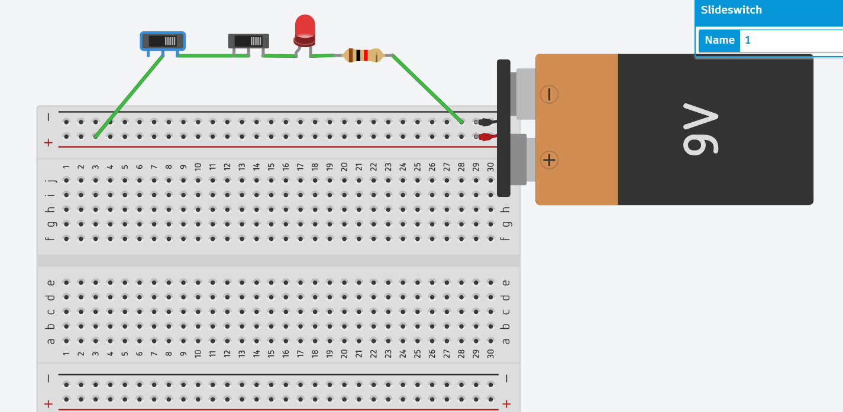
https://www.tinkercad.com/things/gXhOcfYW4qC-and-gate?sharecode=dCwEUF4UFd6Jyrc9dIoIYJmmEBh_5f3EC3dwLvQGN2k

NOT GATE- 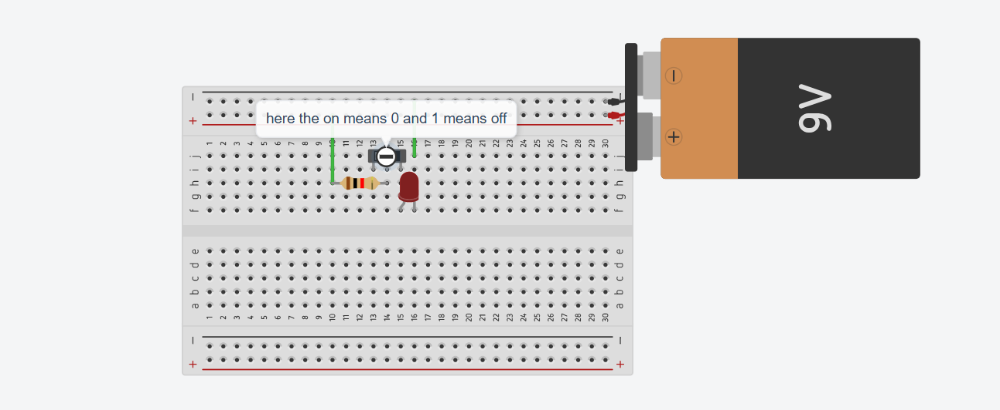

https://www.tinkercad.com/things/1m0qEFJXBjl-not-gate?sharecode=6u6awPtaZ5z6r2IvxsQf3Gb6p3ZI704hkVXF0SMOEQI

XOR GATE-
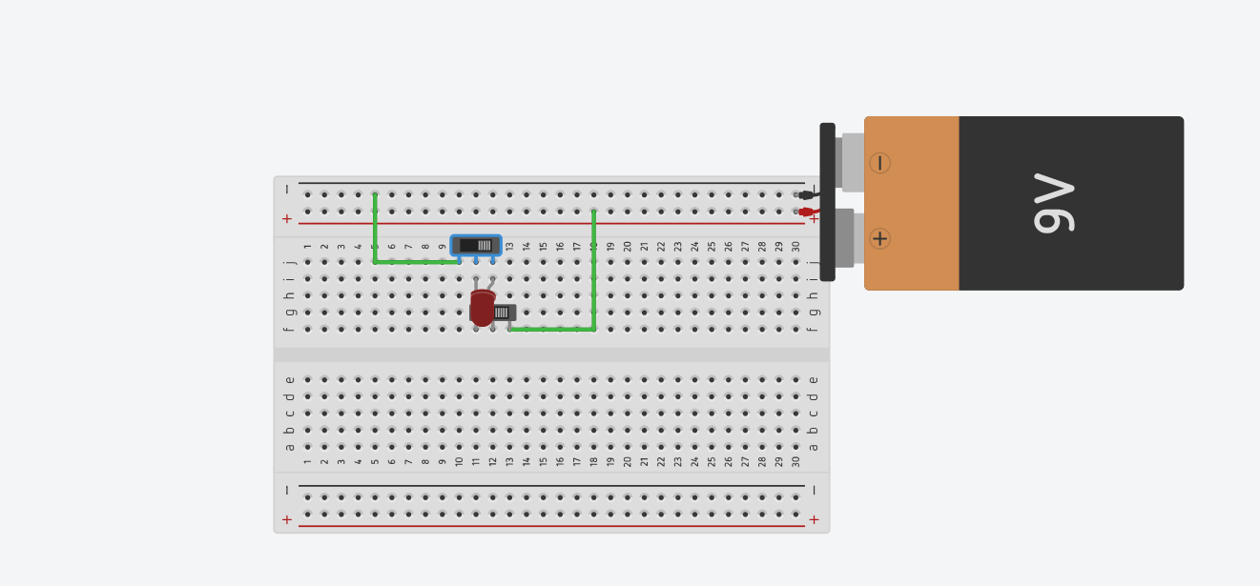
https://www.tinkercad.com/things/cGT6CBG18dB-xor-gate?sharecode=undefined

XNOR GATE- 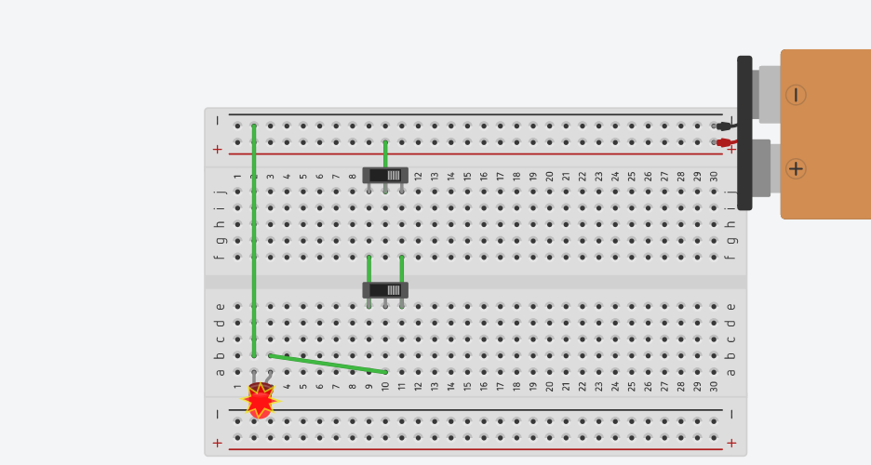
https://www.tinkercad.com/things/gvQTVG0Kb4f-xnor-gate?sharecode=undefined

DIODES-

OR GATE-
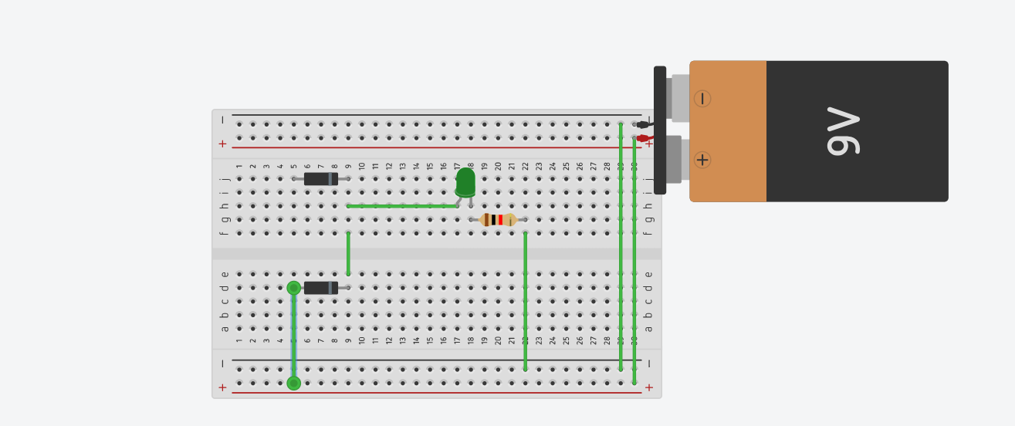
https://www.tinkercad.com/things/jcazyQqwMxV-or-gate-diode?sharecode=undefined

AND GATE-
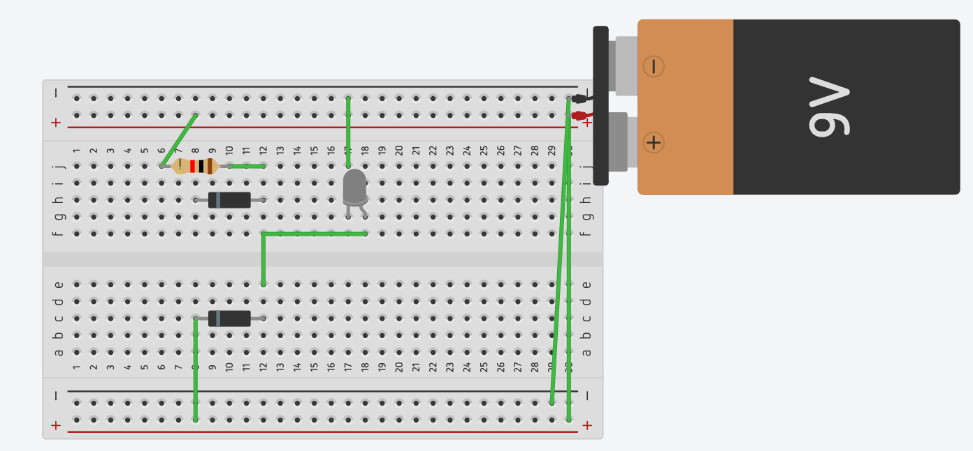
https://www.tinkercad.com/things/kxNixJl2iP7-and-gatediodes?sharecode=ZPHk9HQTMwD4wJmIO4COCxEert0aVEFB5yzbTk59KBc

TRAFFIC LIGHT-
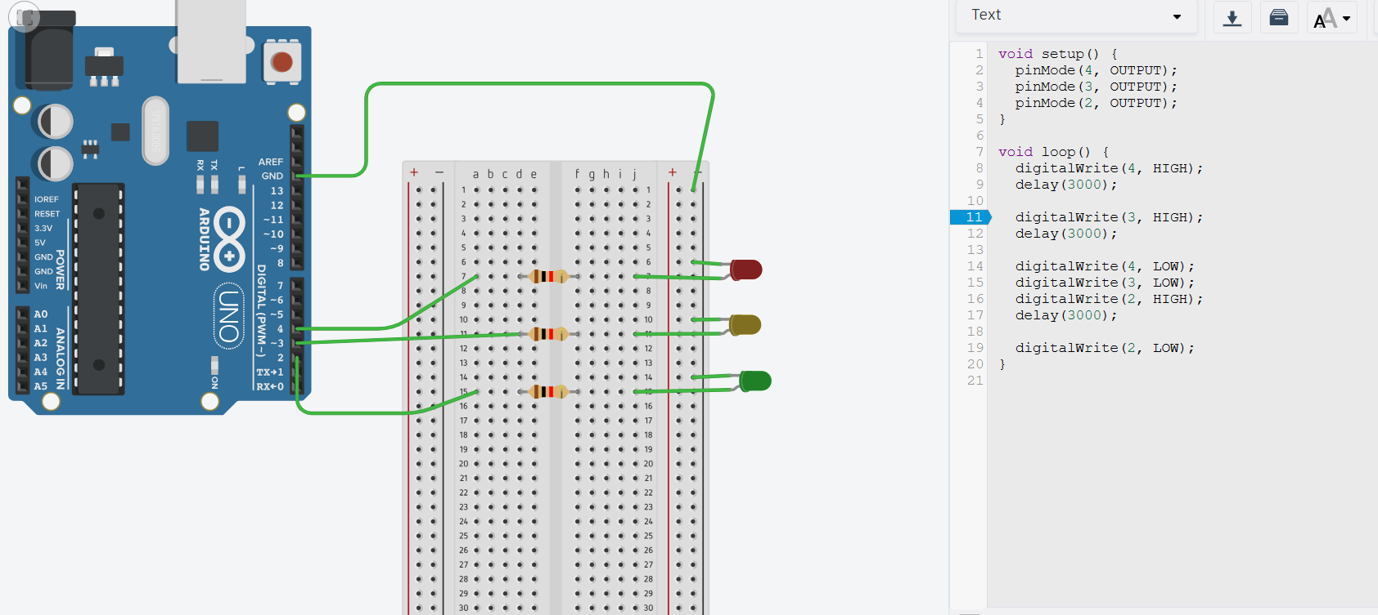
https://www.tinkercad.com/things/0i4WlStsGou-trffic-light?sharecode=1YgPazXJhNlIe-nOKe9gLIsQqopwo04UpckhlLCxuDo

ULTRASONIC SENSOR-
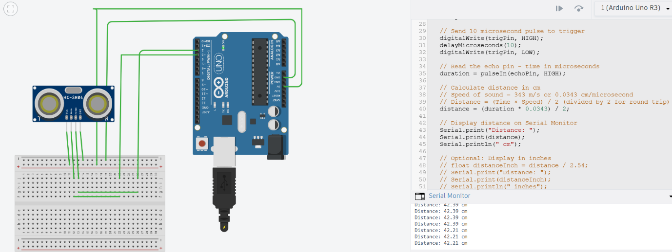
https://www.tinkercad.com/things/8rV26SKqj8y-ultrsonic-sensor?sharecode=undefined

LDR CIRCUIT –

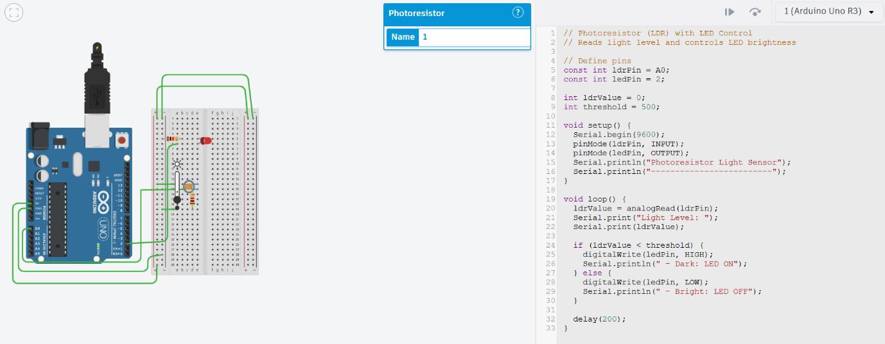
https://www.tinkercad.com/things/4KdR0fy9hTw-ldr-circuit?sharecode=undefined

